|  |
| --- |
| Circle Language Spec: System Objects |

## Use-Command Gets Another Aspect

The Use As Class command is part of the Class aspect but Gets the Object aspect.

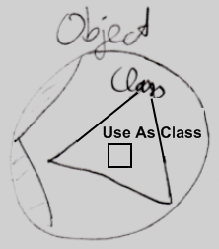

A Use commands Gets a different aspect than what it applies to. The Use Reference As Object command is part of the Object aspect but Gets the Reference aspect. The Use Reference As Class command is part of the Class aspect, but Gets the Reference aspect.

How a Use command delegates to a Get command of the other aspect is not visible in the system interface, because that is private implementation. You only get to see the public members of the system objects, not their implementation.